Project

**Motors on Wheels**

Subject: ICT Project 2: Cycle Report

Lecturer: Ms. Laura Antochi & Dr. Paul



**Submitted By:**

**Group Number 5**

Amandeep Kaur

Deepika Bansal

Dhanam Jayan

Shivani Karlra

**Table of Contents**

**List of Table** ii

**List of Images** ii

Introduction I

Team Description I

Project Members and Individual Contribution I

Beta User stories delivered II

Timeline Projected for Beta Release II

Beta Release User stories demonstration III

Ad Approval and Ad Reject III

Post Ad email notification IV

Filter Option V

Wishlist V

Contact Us VI

References VII

# **List of Table**

Table 1:Beta Release User stories II

# **List of Images**

Image 1:Accept or Reject an Ad III

*Image 2:Ad status pop up on admin 'Accept' or 'Reject' an ad* IV

Image 3:' ads' table in database 'motoronwheels' IV

Image 4:adapprove table in database 'motoronwheels' IV

Image 5:Ad email notification to admin email id IV

Image 6: Filters V

Image 7:Wishlist cars shown under user's profile V

Image 8: Wishlist button VI

Image 9: Contact Us Form VI

# Introduction

The project – ‘Motors on Wheels’ is to create an e-marketplace, offering a platform for users to buy or sell their car. Objective of the project is to overcome the challenges faced by the client in contacting the potential buyers for the car on sale and to manage the deal between car sellers and buyers. As developers working on this project, we followed the client’s specifications to make a website which meets the client’s business nature and requirements.

For the project ‘Motors on Wheels’, Agile methodology is followed, where the project is divided into three iterations that are – Alpha, Beta and Final release. Successful completion of alpha user stories release, project progressed to beta release. Success of Alpha user stories can be measured in terms client’s positive feedback on alpha release user stories. Planning involves in development is a complex process. Agile methodology involves considering the changing customer’s need and adaptive to it (Torrecilla-Salinas, 2015).Project ‘Motors on Wheels’ also involved changes which were continuously being reported to client along with an update on the progress on the client. Effective two-way communication and client’s feedback played a great role in the development of this project. This report will cover

# Team Description

## Project Members and Individual Contribution

**Shivani Karla -**

**Project roles:** Introduction, Beta User Stories detail & demonstration and Timeline

**Amandeep Kaur -**

**Project roles:**

**Deepika Bansal**:

**Project Roles:**

**Dhanam Jayan:**

**Project Roles:**

# Beta User stories delivered

|  |  |  |  |  |
| --- | --- | --- | --- | --- |
| **Number** | **Title** | **Description** | **Priority** | **Time (in days)** |
| 1. | Ad Approval | As an admin I want an option to check the ad posted by seller and approves it. | 10 | 5 |
| 2. | Post Ad email notification | As Admin I want to get an email whenever any new ad is posted on the website, so that Ad can be approved or reject | 10 | 5 |
| 2. | Reject an ad | As an admin I want an option to check the ad posted by seller and approves it. | 10 | 5 |
| 3. | Enquire Now | As a car buyer I need an option to enquire about the car so that I can clear my doubts and proceed. | 10 | 5 |
| 3. | Filter Option | As a car buyer I need few filter options so that I can do the search of car using those filters | 10 | 5 |
| 5. | Wishlist | As a car buyer I need an option to wish list any car, which can later be viewed by me. | 20 | 5 |
| 4. | Contact Us | As a user of website, I need a form so that I can fill the required details and leave a comment or query to the owner of the website | 20 | 3 |
| **Total** | | | | **33** |

Table 1:Beta Release User stories

# Timeline Projected for Beta Release

Beta release timeline was based on below calculation. Beta release time (in days) = Number of weeks * Number of members in group * number of working days.

Thus, Beta release time (in days) = 5*4*2 = 40 days.

As shown in Table 1, number of days utilised in the delivery of beta release user stories were 33 days. Difference of 7 days from the projected timeline is due to following reason –

* In initial 5 days of Beta, feedback on alpha user stories were worked upon. It included some changed in the design such as button colour, navigation bar color etc. and some other changes to search filter fields and functionality. After completing the changes to alpha user stories based on client’s feedback, it was again got tested by client for any other changes to be incorporate.
* Time involved in meeting and defining the priorities for beta user stories with the client.

# Beta Release User stories demonstration

## Ad Approval and Ad Reject

One of the functionalities and user requirement is to have an option, where admin review the Ad posting made by any seller and can approves the Ad. Only on approval of the Ad by admin, the ad will be visible on the website for the uses of it. Similarly, admin can reject an ad.

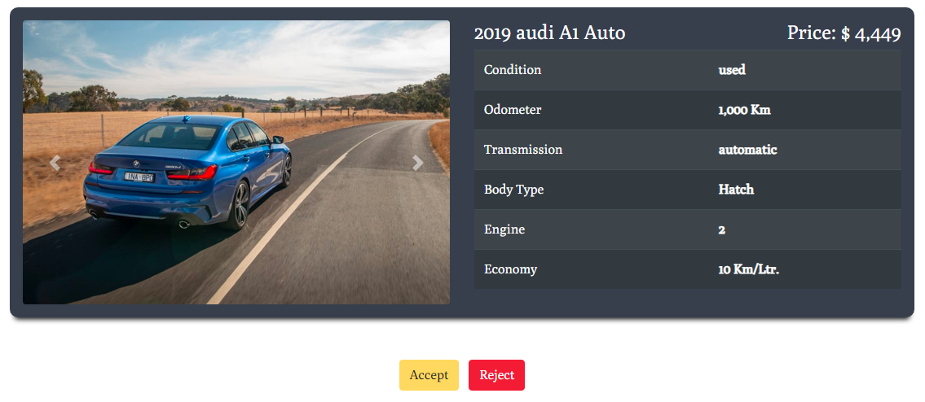

Image 1:Accept or Reject an Ad

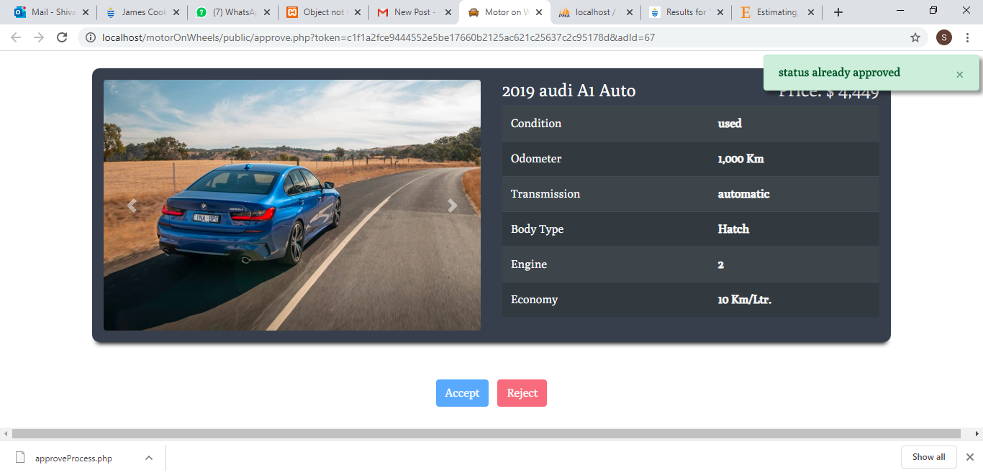

*Image 2:Ad status pop up on admin 'Accept' or 'Reject' an ad*

Database Table Involve: ‘ads’ and ‘adapprove’ tables will get impacted.

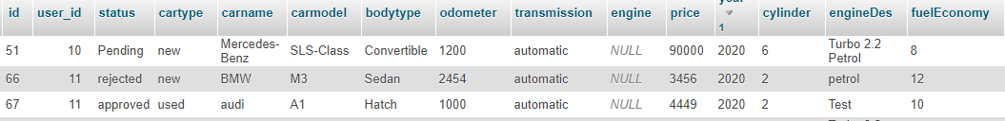

Image 3:' ads' table in database 'motoronwheels'

Image 4:adapprove table in database 'motoronwheels'



## Post Ad email notification

As soon as there is an ad posted through website, admin will get an email notification. Admin can click on Approve link to approve an ad. Link will take the admin to website, where admin is first required to login and then can approve or reject an ad.

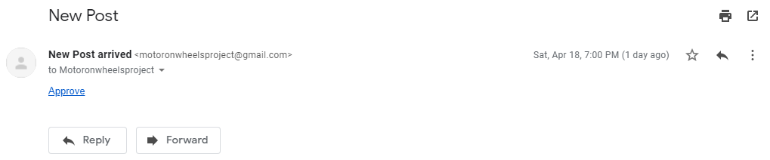

Image 5:Ad email notification to admin email id

## Filter Option

Filter box allow user to do filtered search of a car or can simply click on the button at the bottom of the search filter box to see all the postings or cars.

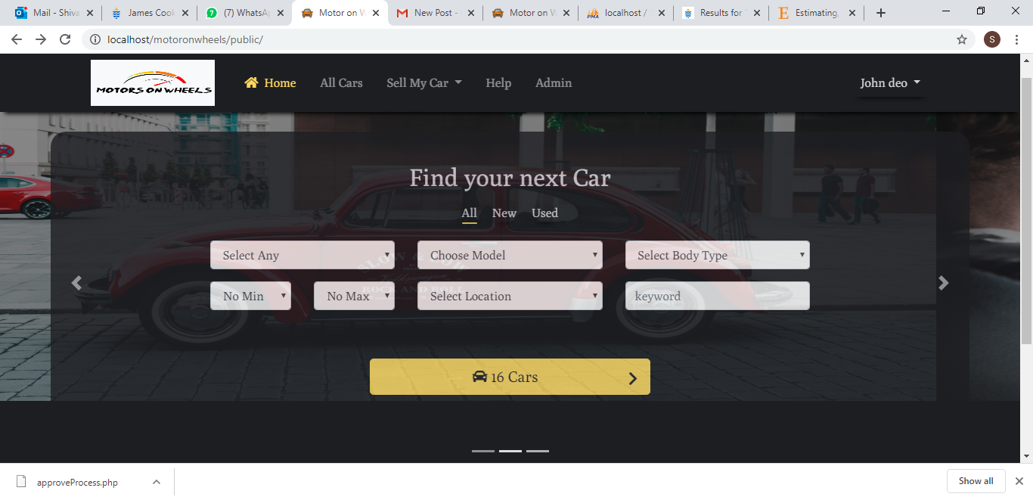

Image 6: Filters

## Wishlist

This option will allow user to add any car to the whishlist to be viewed later. For this user is first required to login and then can wishlist the cars.

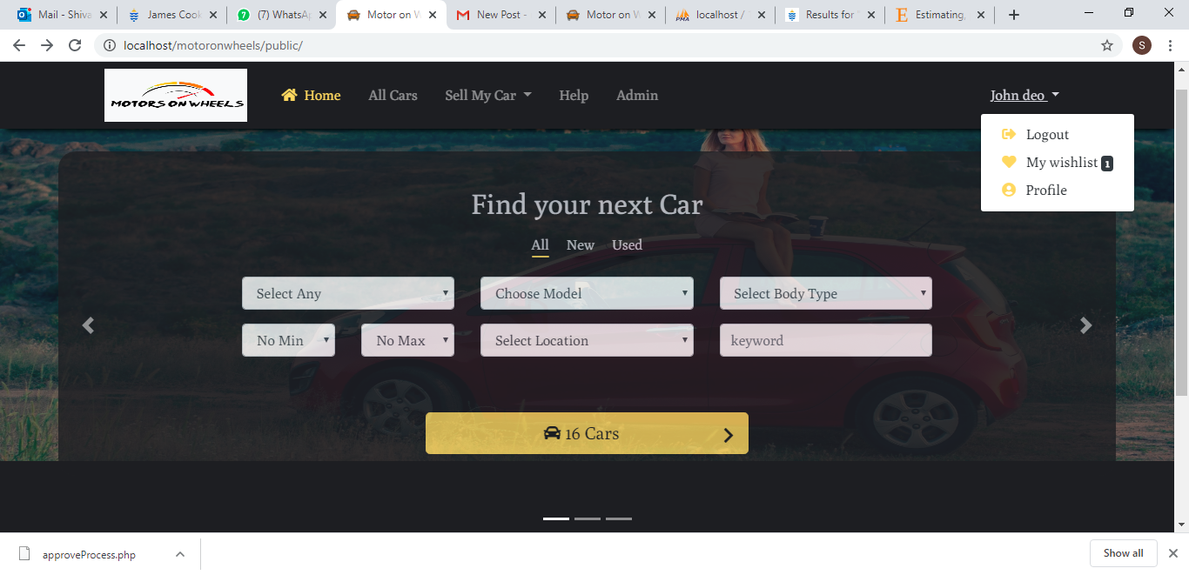

Image 7:Wishlist cars shown under user's profile

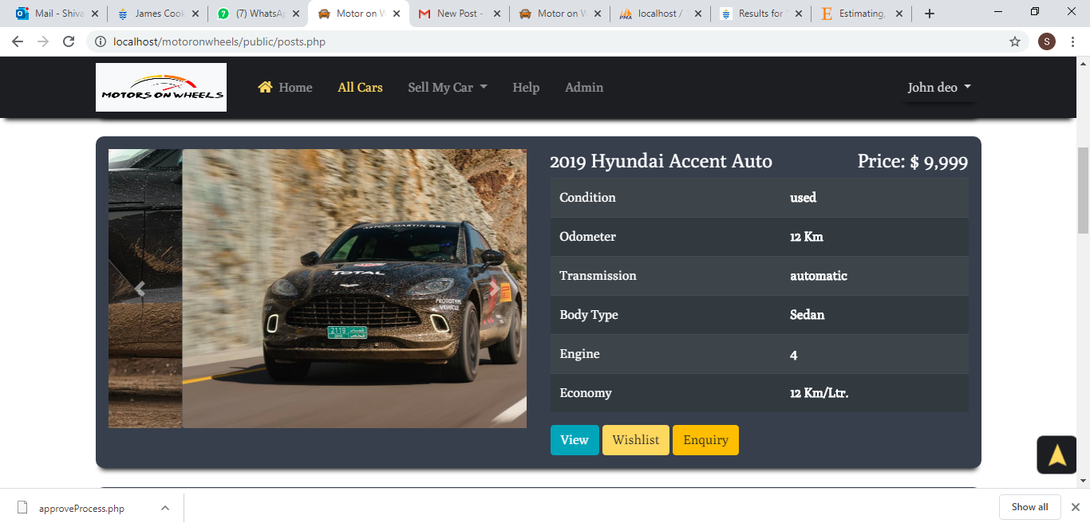

Image 8: Wishlist button

Wishlist Page

## Contact Us

This will allow user to contact for any query or feedback by filling a form.

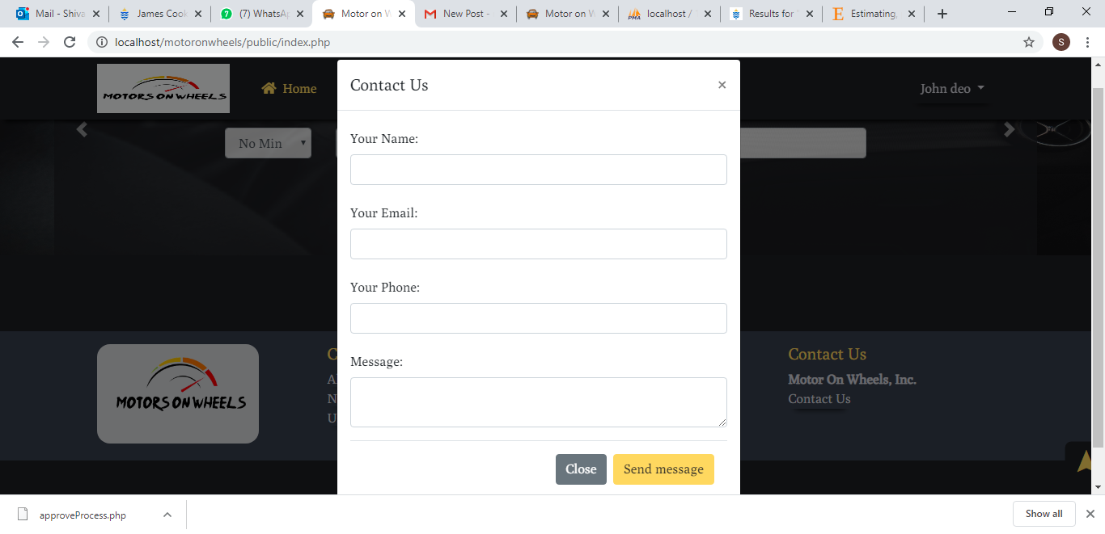

Image 9: Contact Us Form

# References

Torrecilla-Salinas, C. J. (2015, May). Estimating, planning and managing Agile Web development projects under a value-based perspective. *Information and Software Technology, 61*, 124-144. doi:https://doi.org/10.1016/j.infsof.2015.01.006